**USCS3P01:USCS303-Operating System (OS) Practical-05**

**Threads**

Contents

USCS3P01:USCS303-Operating System (OS) Practical-05…………………………………………...1

Threads………………………………………………………………………………………………….1

Practical Date: 13th August,2021(Friday) 2

Practical Aim: Threads(Multi-Threading) 2

Thread States: Life Cycle of a Threads 2

Summation 4

Question-01: 4

Source Code: 4

Output: 7

Primes 7

Question-02: 7

Source Code 1: 8

Source Code 2: 9

Output: 13

Fibonacci 14

Question-03: 14

Source Code: 14

Output: 17

# Practical Date: 13th August,2021(Friday)

# Practical Aim: Threads(Multi-Threading)

# Thread States: Life Cycle of a Threads

**Thread States: Life Cycle of a Threads**

A java thread can be in any of following thread states during its life cycle i.e.

• New,

• Runnable,

• Blocked,

• Waiting,

• Timed Waiting or Terminated

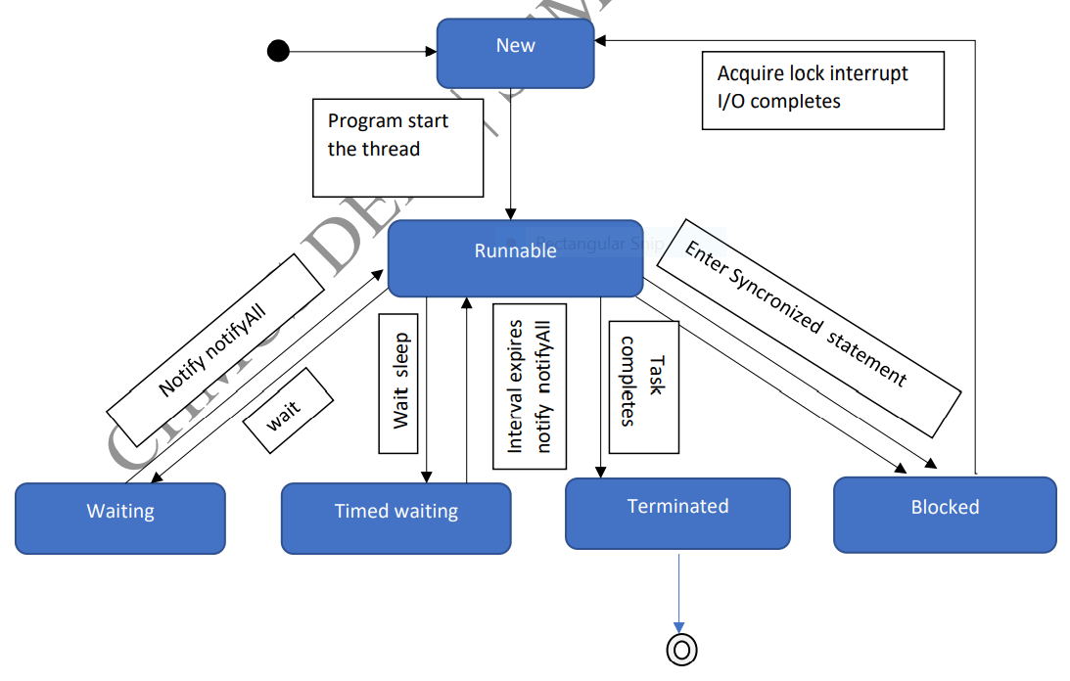

1. **New and Runnable States:**

• A new thread begins its life cycle in the new state.

• It remains in this state until the program starts the thread, which places in the running state.

• A thread in the runnable state is considered to be executing its task.

1. **Waiting State:**

• Sometimes a runnable thread transition to the waiting state while it waits for another thread to perform a task.

• A waiting thread transition back to the runnable state only when another thread notifies it to continue executing.

1. **Timed Waiting State:**

• A runnable thread can enter the timed waiting state for a specified interval of time. It transition back to the runnable state when the time interval expires or when the event it’s waiting for occurs.

1. **Blocked State:**

• A runnable thread transition to the blocked state when it attempts to perform a task that cannot be complete immediately and it must temporarily wait until the task completes.

1. **Terminated State:**

• A runnable thread enters the terminated state (sometimes called dead state) when it successfully completes its task or otherwise terminates (perhaps due to an error).

# Summation

**Summation**

# Question-01:

**Write a multithreaded java program that determines the summation of a non -negative integer. The Summation class implements the Runnable interface. Thread creation is performed by creating an object instance of the Thread class and passing the constructor a Runnable object.**

# Source Code:

//Name:Yash Parab

//Batch No: B1

//PRN:2020016400922513

//Date:14-08-2021

class P5_Q1_Summation_YP implements Runnable

{

int upperLimit,sum;

public P5_Q1_Summation_YP(int upperLimit)

{

this.upperLimit=upperLimit;

}

public void run()

{

for(int i =1;i<=upperLimit;i++)

sum +=i;

}

}//ends of class P5_Q1_Summation_YP

public class P5_Q1_SummationTest_YP

{

public static void main(String args[])

{

if(args.length<= 0)

System.out.println("Usage: P5_Q1_SummationTest_YP<integervalue>");

else

{

int upp = Integer.parseInt(args[0]);

if(upp<=0)

System.out.println("args[0]:" + args[0] + " must be a positive number");

else

{

P5_Q1_Summation_YP s = new P5_Q1_Summation_YP(upp);

Thread t = new Thread(s);

t.start();

try{

t.join();

System.out.println("The sum of first " + upp + " elements is " + (s.sum));

}

catch(Exception e){

e.printStackTrace();

}

}//inner else ends

}//outer else ends

}//main ends

}//end of class class P5_Q1_SummationTest_YP

# Output:

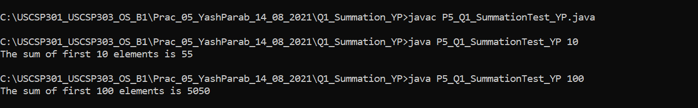

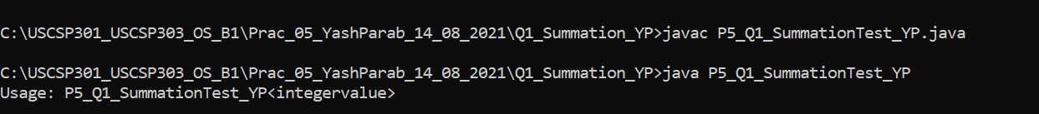

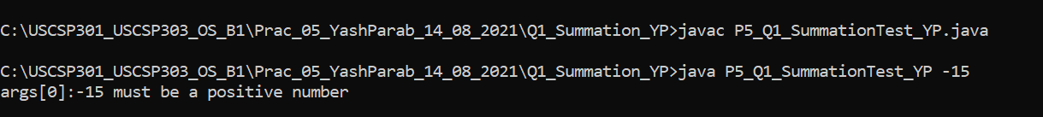

# Primes

**Primes**

# Question-02:

**Write a multithreaded java program that outputs prime numbers. This program should work as follows: The user will run the program and will enter a number on the command line. The program will then create a separate thread that outputs all the prime numbers less than or equal to the numbers entered by the user.**

# Source Code 1:

//Name:Yash Parab

//Batch No: B1

//PRN:2020016400922513

//Date:14-08-2021

import java.io.*;

import java.util.*;

public class P5_Q2_Primes_YP {

public static void main(String args[]){

try{

P5_Q2_PrimeThread_YP pt = null;

System.out.print("Enter a number>");

Scanner scan = new Scanner(System.in);

int limit = scan.nextInt();

System.out.print("Enter a file name to store the results > ");

String fName = scan.next();

if(fName.length()>0)

pt = new P5_Q2_PrimeThread_YP(limit, new

FileOutputStream(fName));

else

pt = new P5_Q2_PrimeThread_YP(limit);

pt.run();

}catch(Exception e){

e.printStackTrace();

}

}//main ends

}//class ends

# Source Code 2:

//Name:Yash Parab

//Batch No: B1

//PRN:2020016400922513

//Date:14-08-2021

import java.io.*;

class P5_Q2_PrimeThread_YP extends Thread {

private PrintStream pOut = null;

private int limit = 0;

//default constructor.does nothing

public P5_Q2_PrimeThread_YP(){

}

//constructor to set the number below which to generate primes

//no output stream is specified,so it outputs to the System.out

public P5_Q2_PrimeThread_YP(int I){

limit = I;

try{

pOut = System.out;

}catch(Exception e){

e.printStackTrace();

}

}

//constructor that sets both the number, as above, and specifies an output stream

//if the specified stream is null, uses System.out

public P5_Q2_PrimeThread_YP(int I, OutputStream outS){

limit = I;

try{

if(outS != null){

pOut = new PrintStream(outS);

}else{

pOut = System.out;

}

} catch(Exception e){

e.printStackTrace();

}

}

//method that performs the work of the thread,

//in this case the generation of prime numbers.

public void run(){

//compute primes via the seive

boolean numbers[] = new boolean[limit+1];

numbers[0] = false;

numbers[1] = false;

for(int i = 2; i<numbers.length; i++){

numbers[i] = true;

}

for(int i = 2; i<numbers.length; i++){

if(numbers[i]){

for(int j=(2*i);j< numbers.length;j+=i){

numbers[j] = false;

}//inner for ends

}//if ends

}//outer for ends

for(int i=0;i< numbers.length;i++){

if(numbers[i])

pOut.println(i);

}//for ends

}//run ends

}//class ends

# Output:

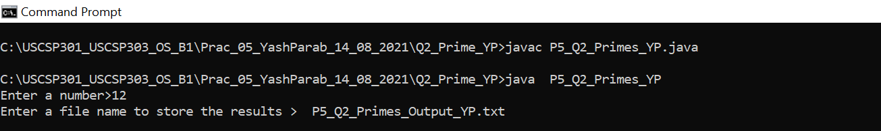

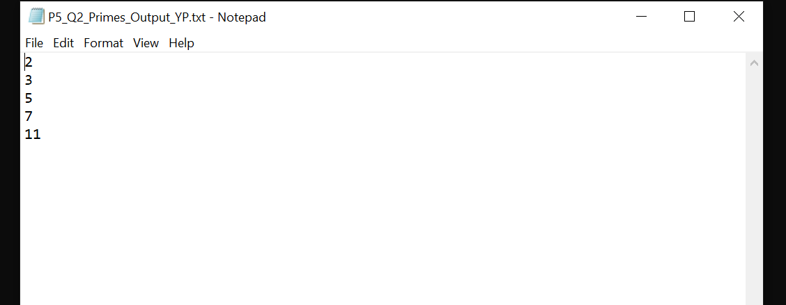

# Fibonacci

**Fibonacci**

# Question-03:

**The Fibonacci sequence is the series of numbers 0, 1, 1, 2, 3, 5, 8, ….Formally, it can be expressed as : fib0 = 0, fib1 = 1, fibn = fibn-1 + fibn-2.Write a multithreaded program that generates the Fibonacci sequence using either the Java.**

# Source Code:

//Name:Yash Parab

//Batch No: B1

//PRN:2020016400922513

//Date:14-08-2021

import java.util.ArrayList;

import java.util.Scanner;

public class P5_Q3_Fibo_YP

{

public static void main(String args[]){

Scanner scan = new Scanner(System.in);

ArrayList al = new ArrayList();

int a;

System.out.println("Enter the number: ");

a = scan.nextInt();

P5_Q3_FiboThread_YP fibTh = new P5_Q3_FiboThread_YP(a);

fibTh.start();

try{

fibTh.join();

}catch(InterruptedException ex){

ex.printStackTrace();

}

int fseries[] = fibTh.arr;

System.out.println("First "+a+" fibonacci numbers are:");

for(int i=0;i<a;i++){

System.out.println(fseries[i]+ "");

}

}//main ends

}//class ends

class P5_Q3_FiboThread_YP extends Thread

{

private int a,i;

Thread t;

int arr[];

public P5_Q3_FiboThread_YP(int a){

this.a = a;

arr = new int[a];

}

public void run(){

arr[0] = 0;

arr[1] = 1;

for(i=2;i<a;i++){

arr[i] = arr[i-1] + arr[i-2];

}

}//run ends

}//class ends

# Output:

